Y2Q4W2

Jesus teaches about prayer

Ask: If you had a friend who never talked to you would you be good friends?
Ask: What if you had a friend who talked all the time and never let you say anything?
Ask: What about someone who only wants to talk about them?

Say: For people to become good friends they need to both talk and listen to each other.
Ask: God wants to be our friend, but how do we talk to Him?
Say: Today we are learning about some of the things that Jesus taught His disciples about prayer.

Bible Story

Sing Songs

Return to tables
Memory Verse: Fill in the blanks and then say the memory verse on the colouring page.

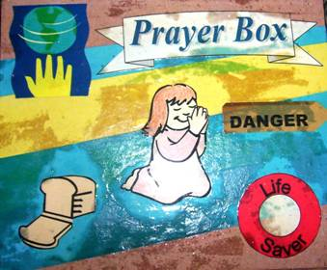
Craft: Top of box
- Add Label "Prayer Box"
- Praying child, world, bread, danger sign and life saver

Discuss the following depending on age, interest and time:
Discuss each phrase of Jesus prayer – what do they mean? What other things could be covered by each phrase? (eg. food = material needs)
Discuss how we talk to God and how He talks to us
Discuss how often we talk to our friends and how often we should talk to God
What sort of things can we say to God?
Why is prayer important?

Handout the prayer cards to be kept in the prayer boxes.

Prayer Card Craft:
- Trace your "praying" hand onto the card over the "My Prayer" title and colour it in.
- In the card, using the guide on the left side, finish each of the sentences on the right to make a prayer. The prayer card suggestions may be used instead of writing.

Ask: How often should we pray?
Ask: What should we talk about when we pray?

Finish with prayer at each table. The children may say their prayers out loud for a small group or quietly for a large group, and then the teacher can finish.

